Nexus: <https://www.youtube.com/watch?v=yZFvJEygn_g>

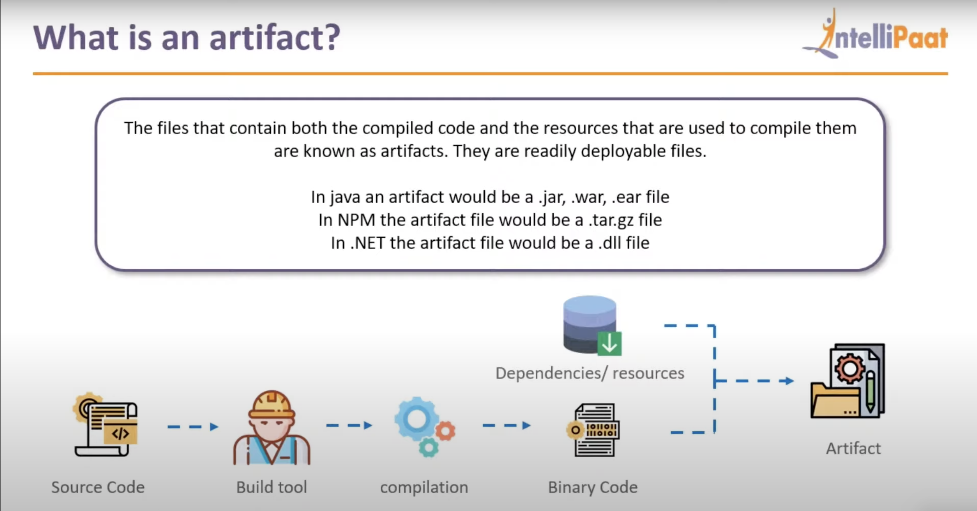

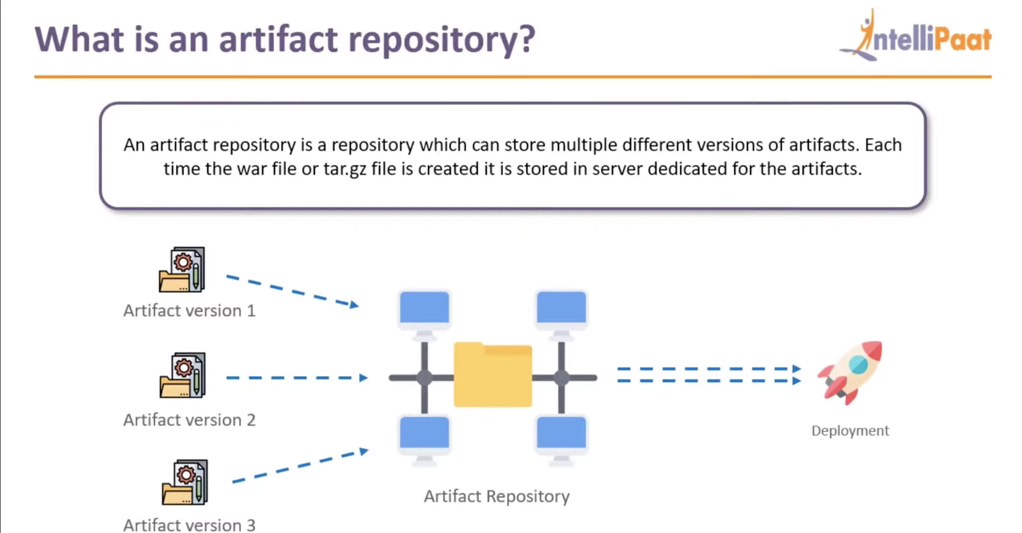

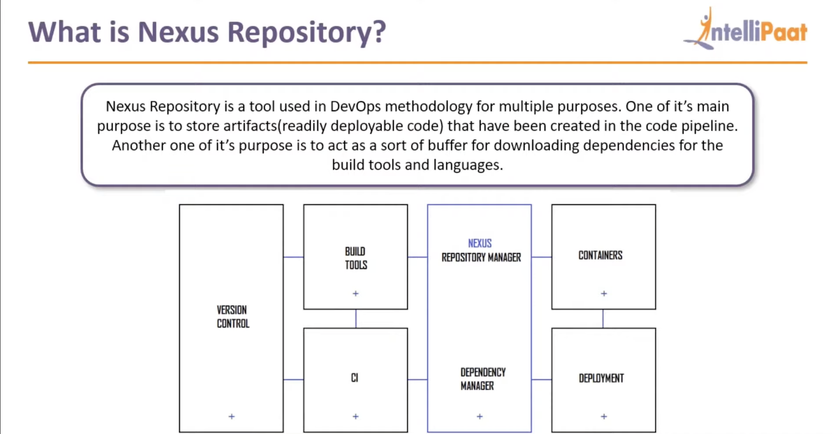

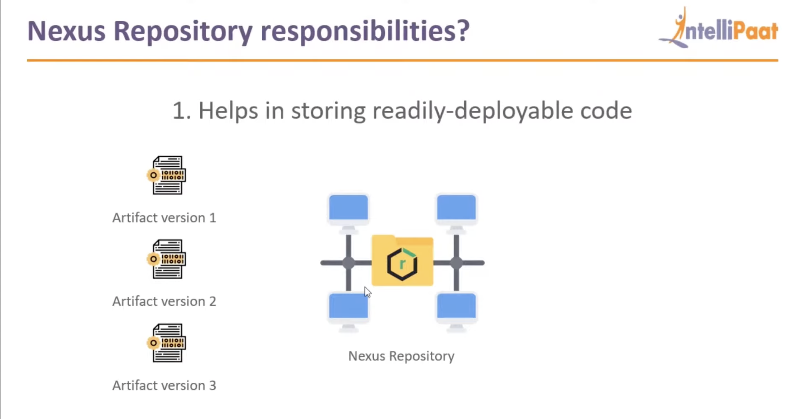

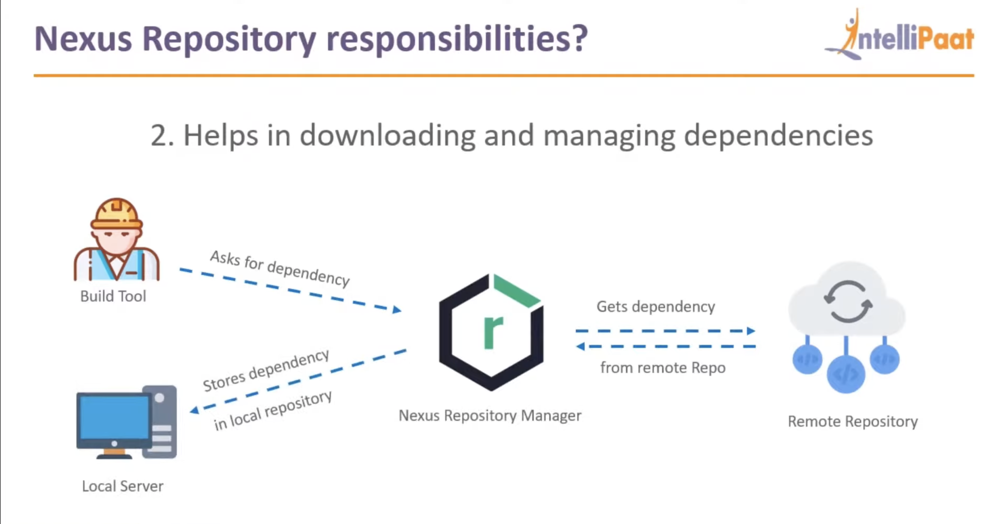

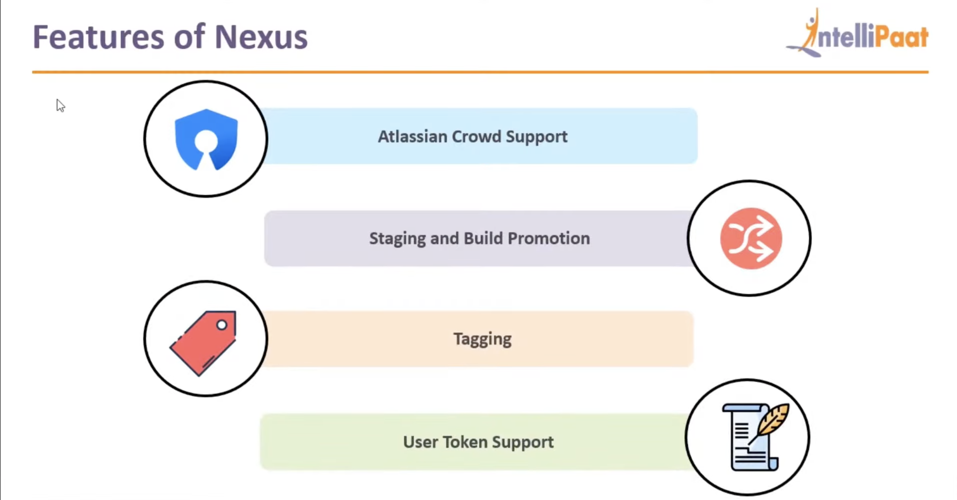

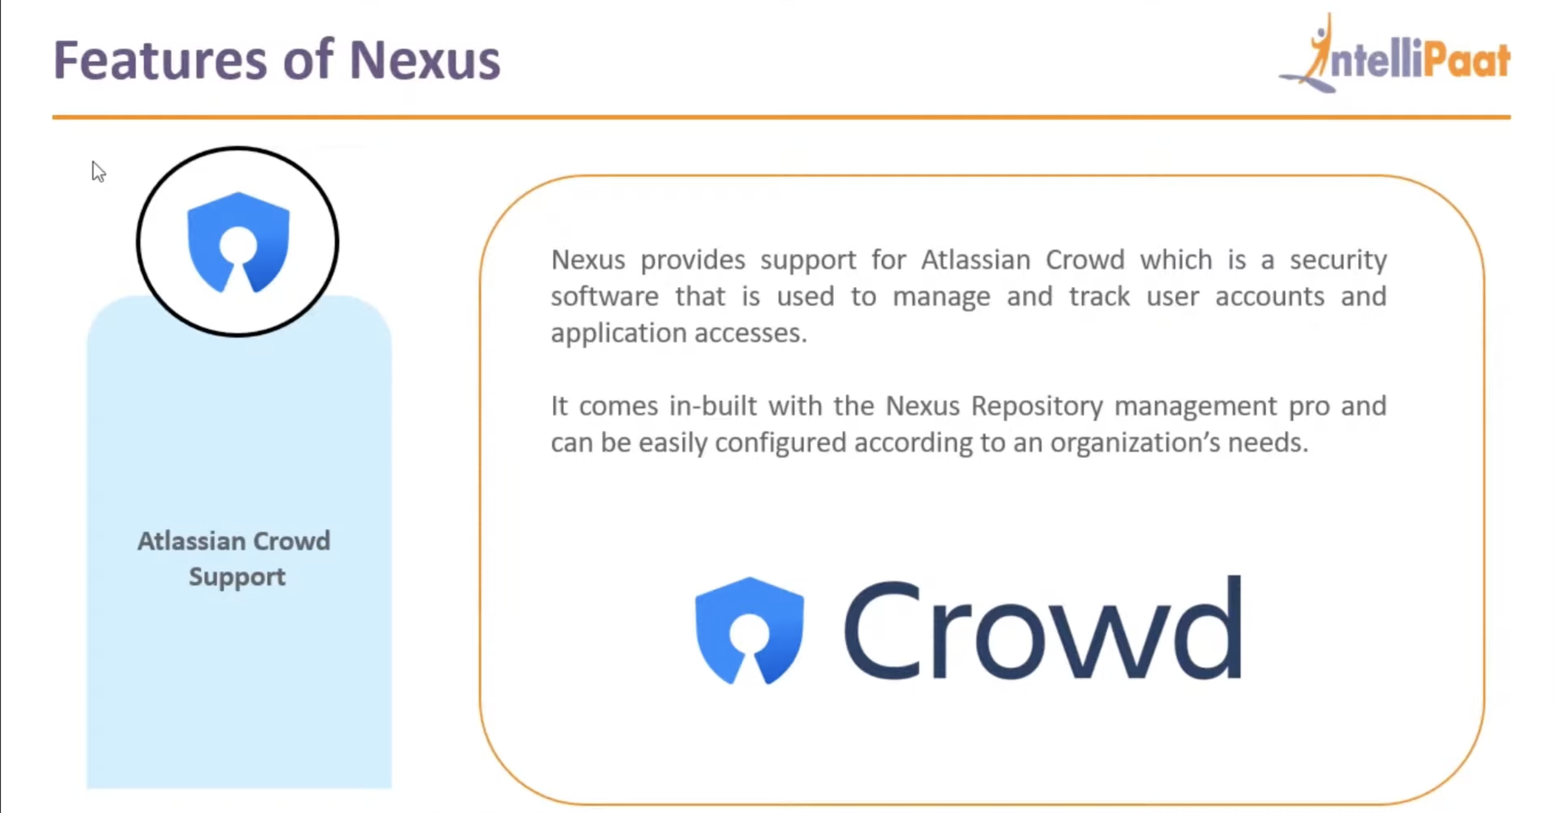

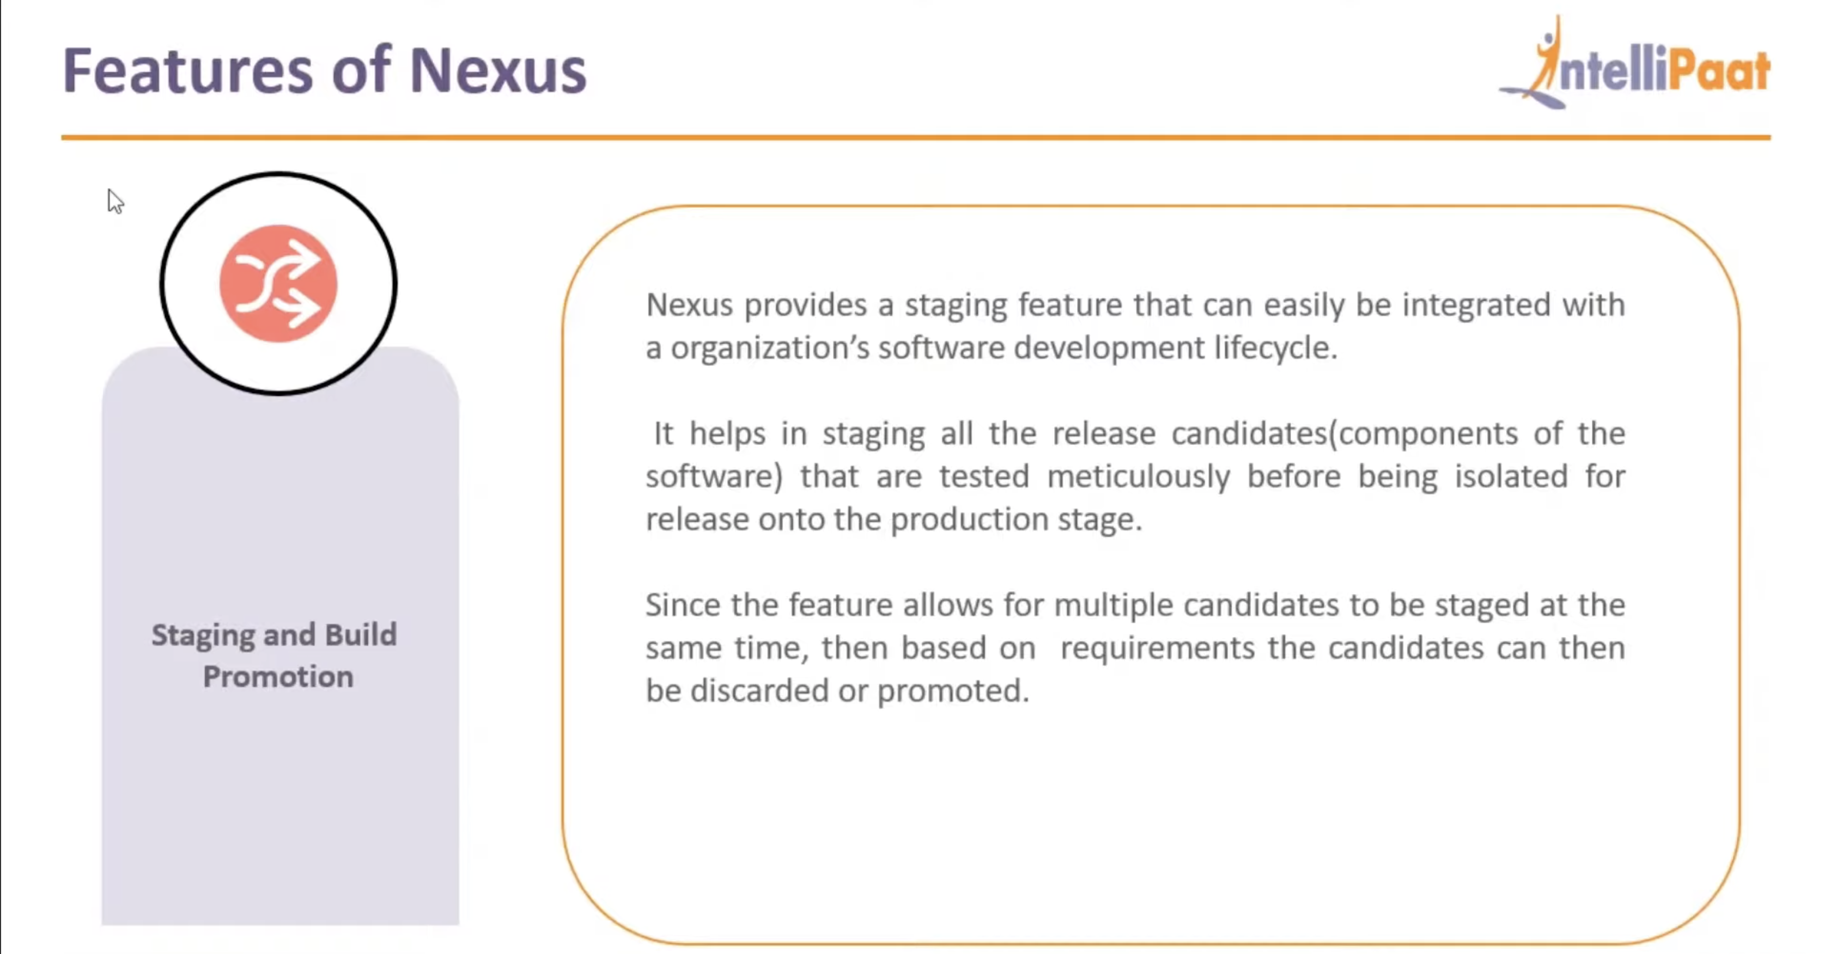

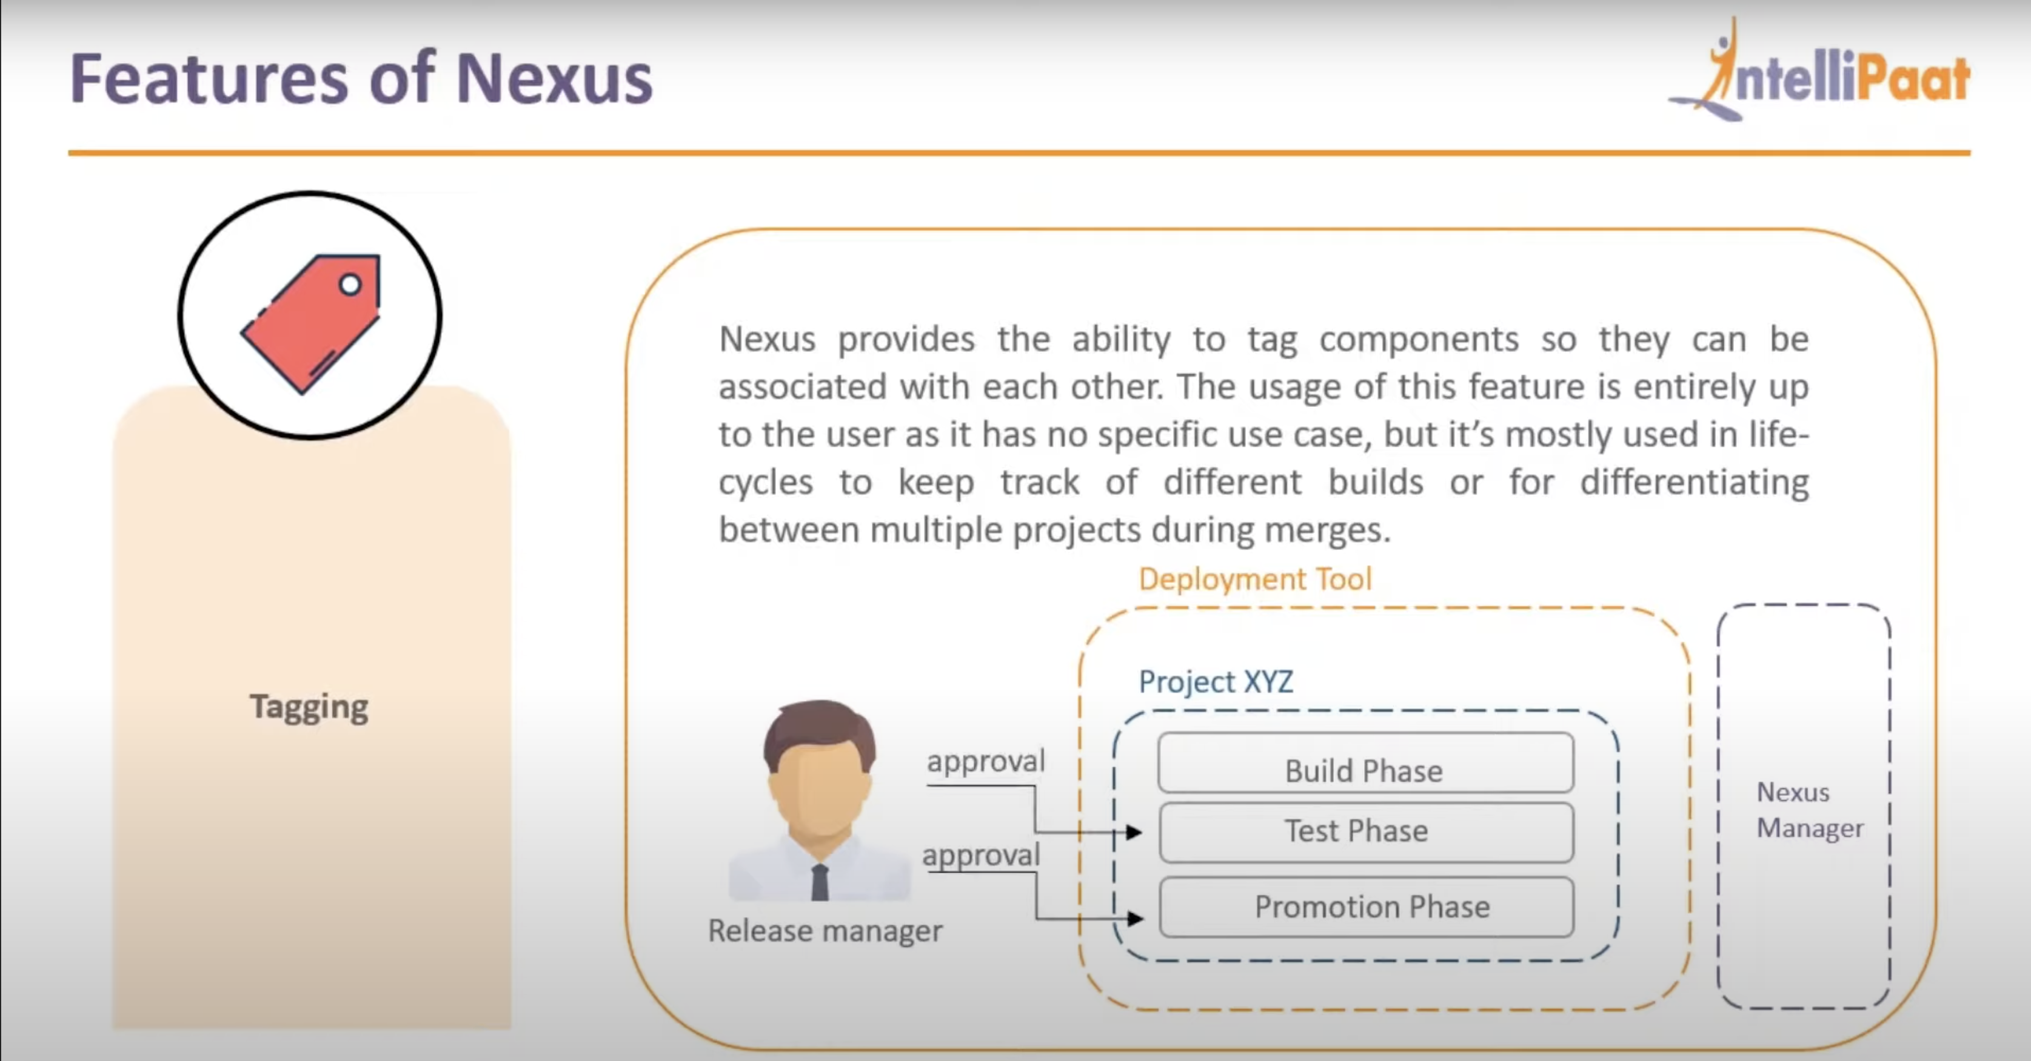

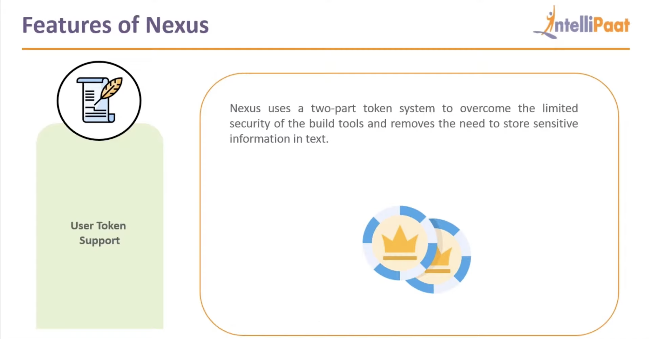

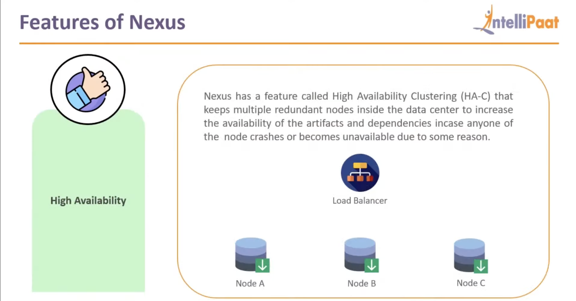

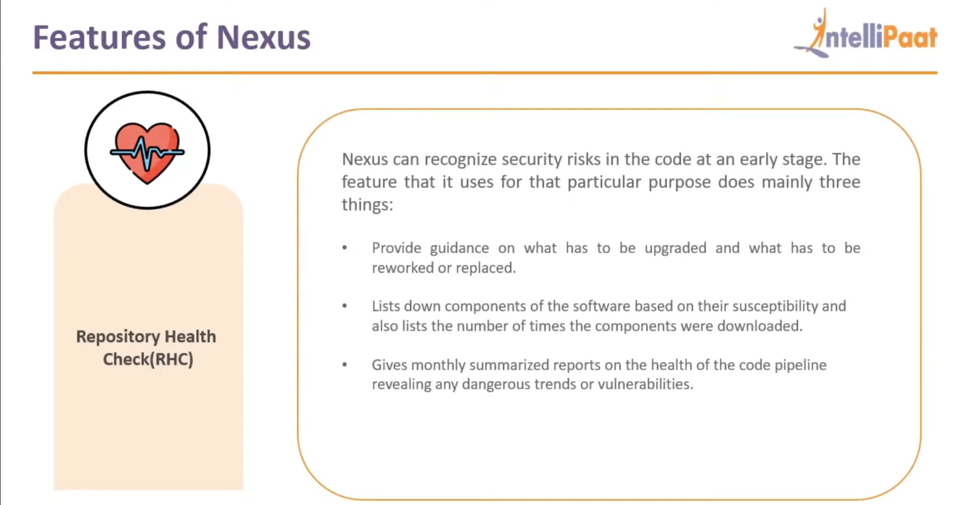

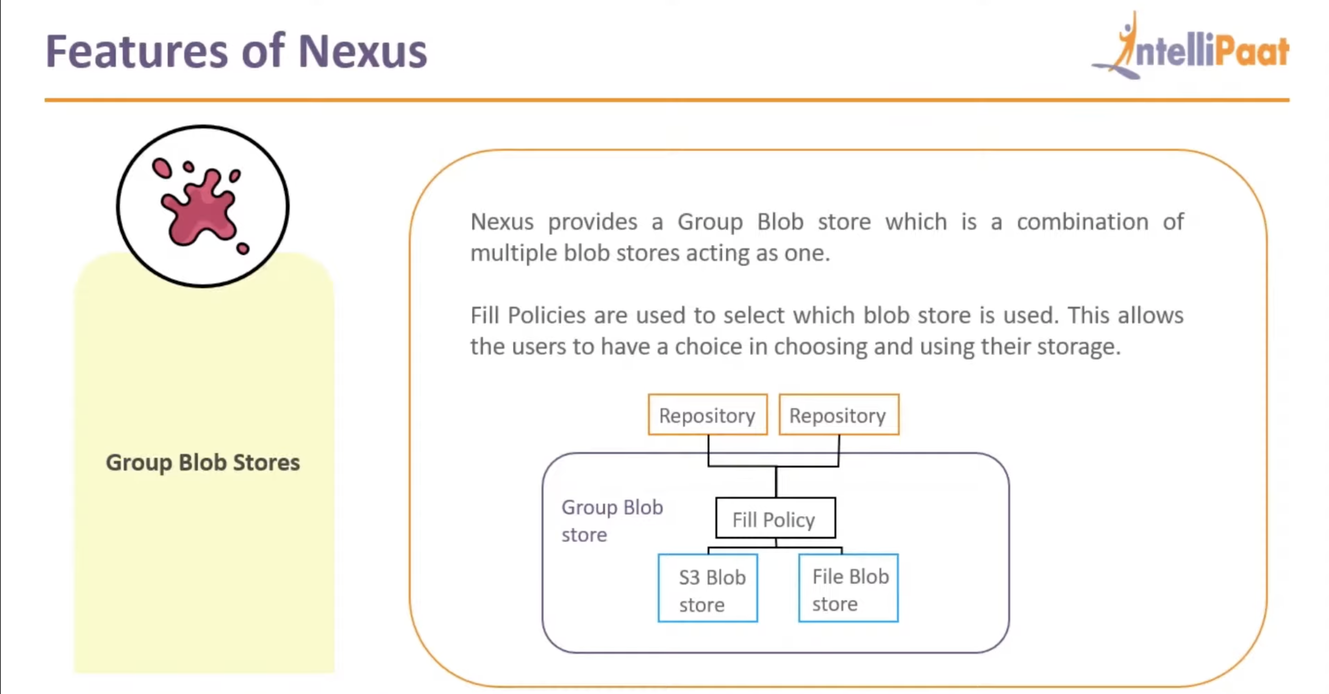

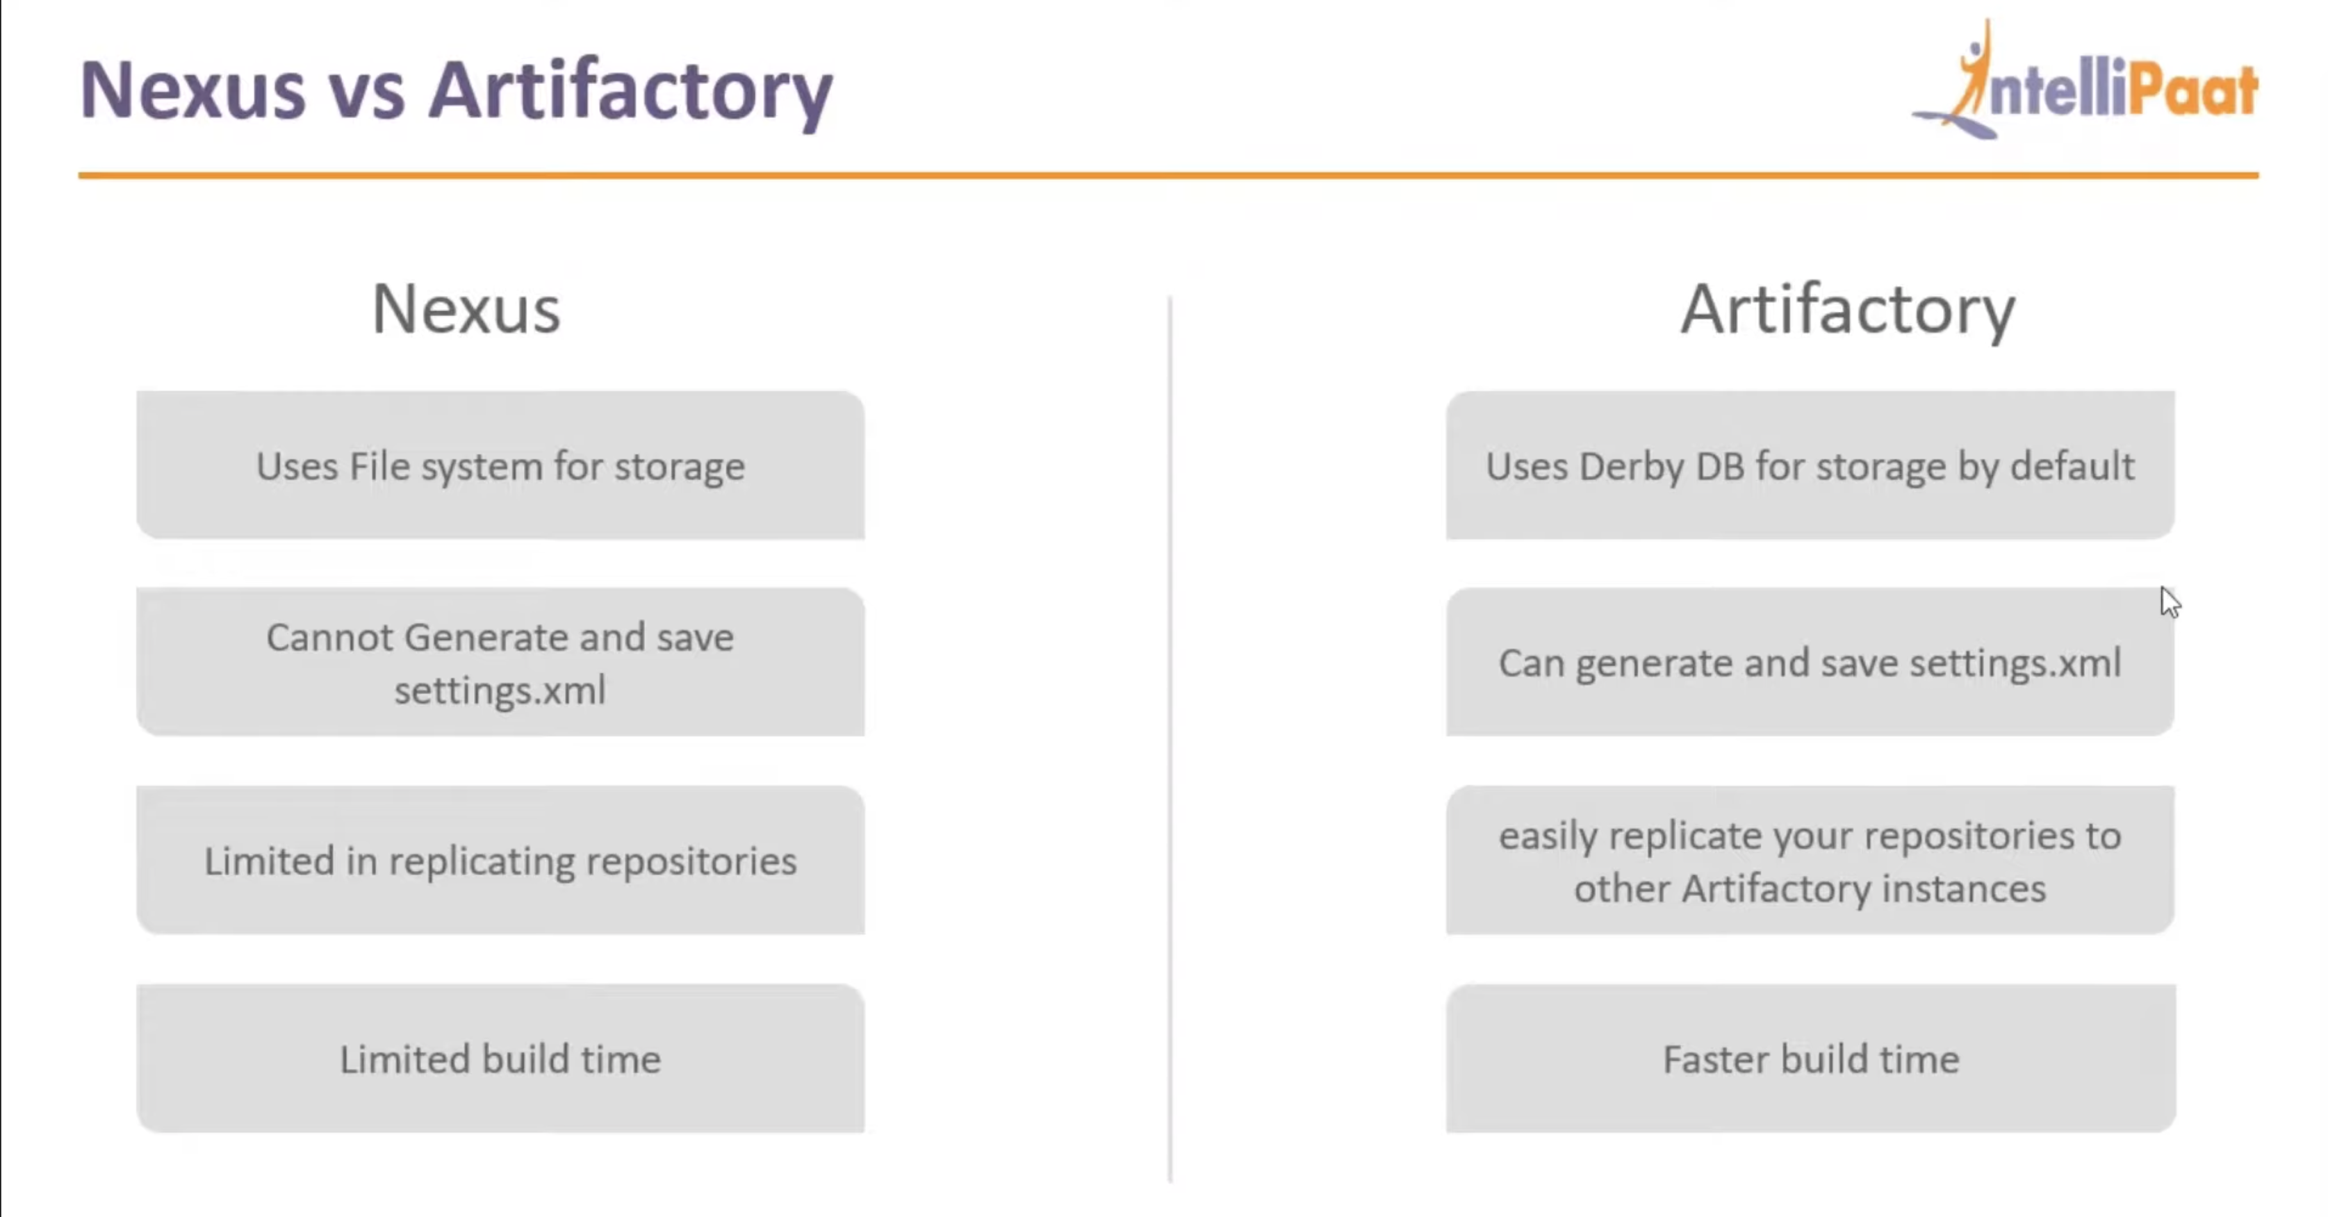

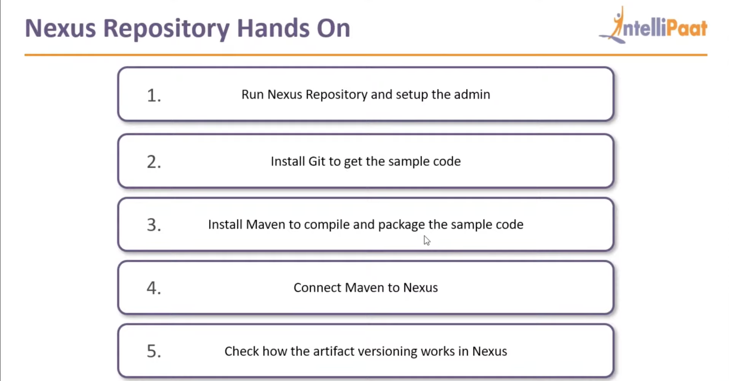

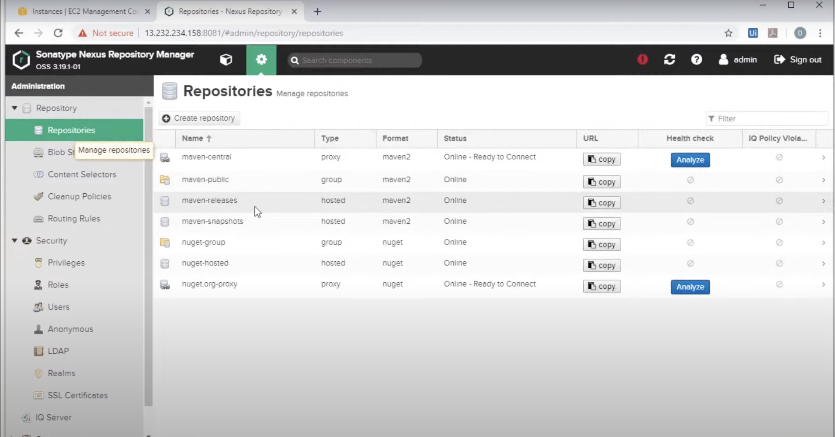

Need to install maven to build our source code.

Then, we need to connect maven to nexus.

So add nexus repo url in the m2 settings file – refer next image

Connected nexus with maven:  
video ref-🡪  
<https://www.youtube.com/watch?v=yZFvJEygn_g>

.m2/settings

<?xml version="1.0" encoding="UTF-8"?>

<settings xmlns="http://maven.apache.org/SETTINGS/1.1.0" xmlns:xsi="http://www.w3.org/2001/XMLSchema-instance" xsi:schemaLocation="http://maven.apache.org/SETTINGS/1.1.0 http://maven.apache.org/xsd/settings-1.1.0.xsd">

<servers>

<server>

<username>admin</username>

<password>p@ssw0rd</password>

<id>nexus</id>

</server>

</servers>

<mirrors>

<mirror>

<id>repo</id>

<name>nexus-repo</name>

<url>http://192.168.1.2:8081/repository/maven-public/</url>

<mirrorOf>\*</mirrorOf>

</mirror>

</settings>

Pom.xml update:

<distributionManagement>

<repository>

<id>nexus</id>

<url>http://192.168.1.2:8081/repository/maven-releases/</url>

</repository>

<snapshotRepository>

<id>snapshots</id>

<url>http://192.168.1.2:8081/repository/maven-snapshots/</url>

</snapshotRepository>

</distributionManagement>

New generation of project:

mvn archetype:generate -DgroupId=com.mycompany.app -DartifactId=test -DarchetypeArtifactId=maven-archetype-quickstart -DarchetypeVersion=1.4 -DinteractiveMode=false

Error during deploy:

[INFO] Installing /home/granga401/projects/test/target/test-1.0-SNAPSHOT.jar to /home/granga401/.m2/repository/com/mycompany/app/test/1.0-SNAPSHOT/test-1.0-SNAPSHOT.jar

[INFO] Installing /home/granga401/projects/test/pom.xml to /home/granga401/.m2/repository/com/mycompany/app/test/1.0-SNAPSHOT/test-1.0-SNAPSHOT.pom

[INFO]

[INFO] --- maven-deploy-plugin:2.8.2:deploy (default-deploy) @ test ---

[INFO] ------------------------------------------------------------------------

[INFO] BUILD FAILURE

[INFO] ------------------------------------------------------------------------

[INFO] Total time: 01:12 min

[INFO] Finished at: 2021-07-12T11:42:07-04:00

[INFO] ------------------------------------------------------------------------

[ERROR] Failed to execute goal org.apache.maven.plugins:maven-deploy-plugin:2.8.2:deploy (default-deploy) on project test: Deployment failed: repository element was not specified in the POM inside distributionManagement element or in -DaltDeploymentRepository=id::layout::url parameter -> [Help 1]

[ERROR]

[ERROR] To see the full stack trace of the errors, re-run Maven with the -e switch.

[ERROR] Re-run Maven using the -X switch to enable full debug logging.

[ERROR]

[ERROR] For more information about the errors and possible solutions, please read the following articles:

[ERROR] [Help 1] http://cwiki.apache.org/confluence/display/MAVEN/MojoExecutionException